One-step and two-step timestamping
This distinction sits right at the heart of how PTP achieves hardware-level accuracy.
The problem it solves is subtle but important: how do you embed a transmit timestamp into a frame when you do not know what that timestamp will be until after the frame has already left the port?

The fundamental problem
When a PTP master wants to send a Sync message, it needs to tell the slave precisely when the frame was transmitted — specifically, when the SFD (Start Frame Delimiter) crossed the MDI (Media Dependent Interface) boundary.
But that moment has not happened yet when the frame is being constructed in software.
The frame must be built, handed to the MAC, queued, and then transmitted. The hardware timestamp is only captured at the instant of transmission — which is after the frame content is already frozen.
This is the chicken-and-egg problem: the timestamp belongs inside the frame, but the timestamp does not exist until the frame is on the wire.
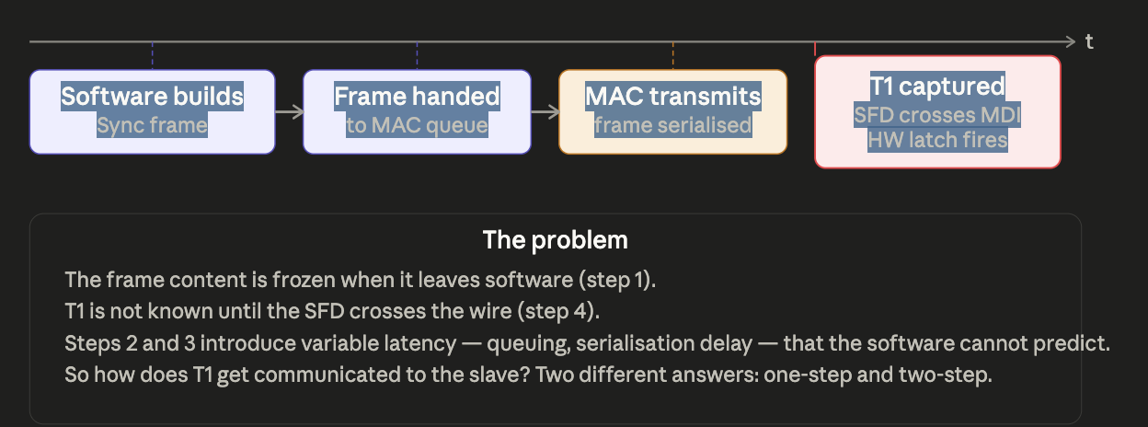

The variable latency between software handing the frame to the MAC and the frame actually leaving the wire (steps 2 and 3) is unpredictable — it depends on queue depth, link speed, and inter-frame gaps. It can be anywhere from tens of nanoseconds to several microseconds. Software cannot predict it, so it cannot pre-fill the timestamp field with the correct value.

Two-step timestamping — send now, report later
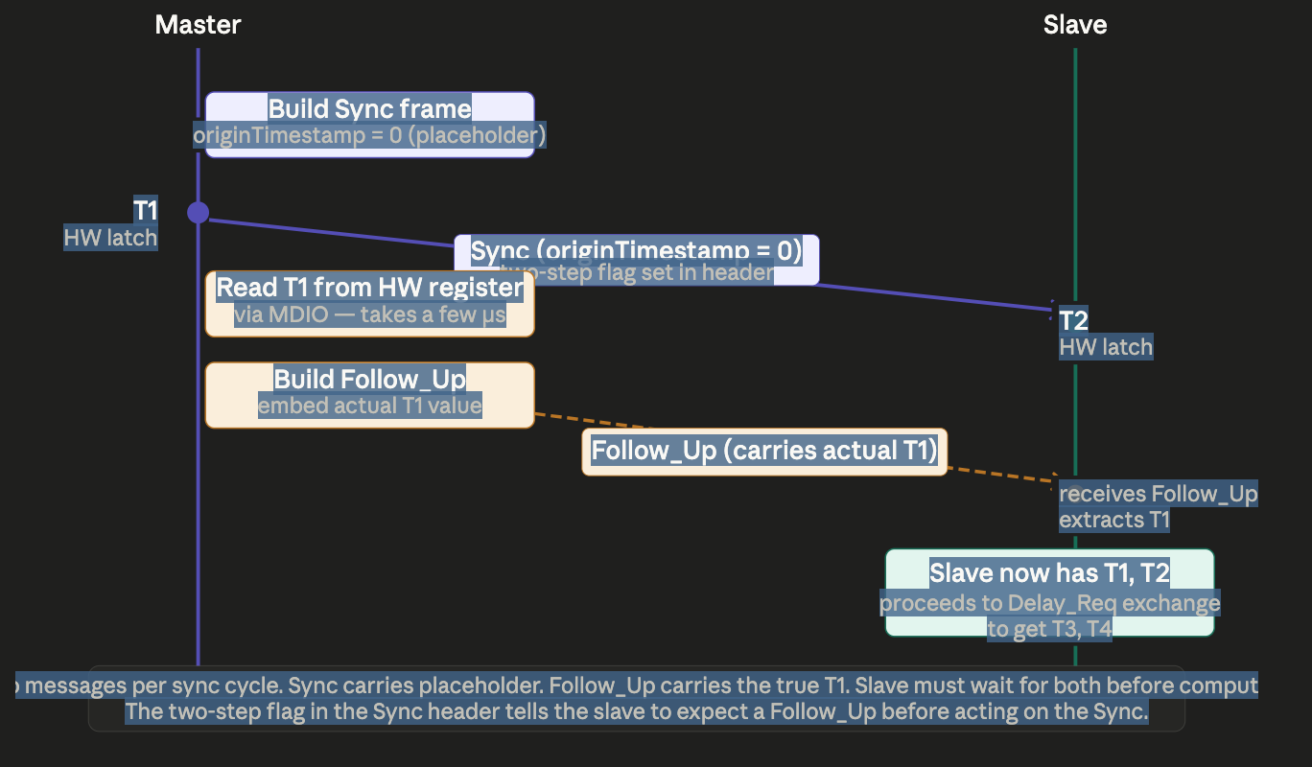
Two-step is the simpler approach conceptually. It sidesteps the problem entirely by using two separate messages.
How two-step works in detail:
- Software builds the Sync frame with the originTimestamp field set to zero — a deliberate placeholder. The two-step flag is set in the Sync header so the slave knows to wait for a Follow_Up.
- The Sync is transmitted. At the instant the SFD crosses the MDI, the hardware timestamp unit latches T1 into a register.
- Software reads T1 from that hardware register via MDIO. This typically takes a few microseconds — entirely after the Sync has left the wire.
- Software builds a Follow_Up message, embeds the actual T1 value in its preciseOriginTimestamp field, and sends it.
- The slave receives both the Sync (giving it T2) and the Follow_Up (giving it T1). It now

One-step timestamping — the hardware writes the timestamp into the frame in flight
One-step eliminates the Follow_Up entirely. The hardware timestamp is written directly into the originTimestamp field of the Sync frame as it passes through the transmit path — after the frame has been committed to the wire but the timestamp field has been retroactively corrected.

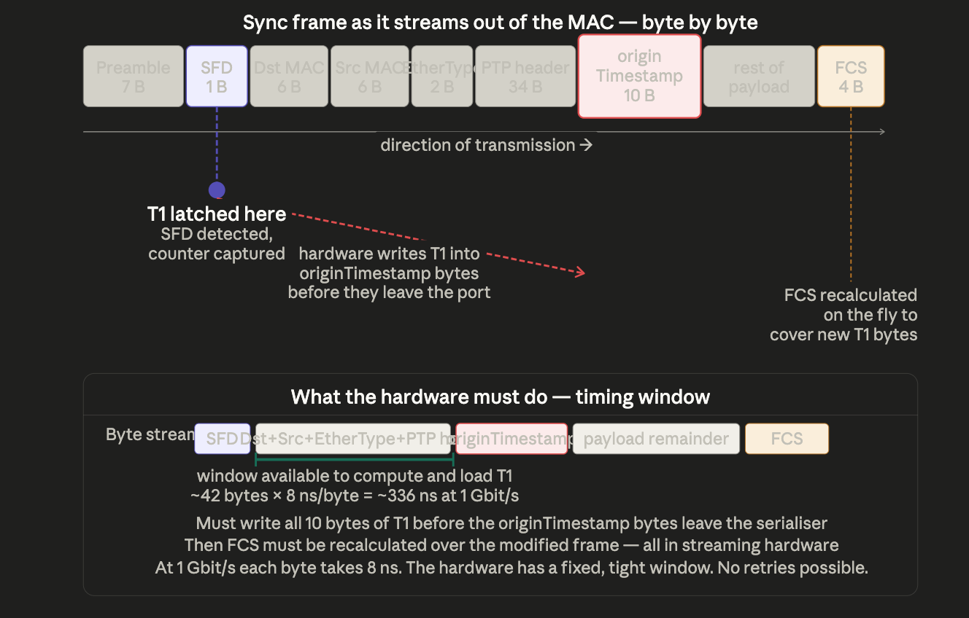
How one-step works in detail:
The key insight is that by the time the originTimestamp field is about to leave the serialiser, 42 bytes of the frame have already gone out (preamble 7 B + SFD 1 B + Dst MAC 6 B + Src MAC 6 B + EtherType 2 B + PTP header 34 B ≈ 56 bytes, but the SFD is where T1 is captured, so the window from SFD to originTimestamp is about 48 bytes). At 1 Gbit/s each byte takes 8 ns, so the hardware has approximately 384 ns to capture T1 and write it into the outgoing byte stream.
This requires dedicated silicon — a hardware state machine that:
- Recognises a PTP Sync frame by its EtherType (0x88F7) and message type field.
- Notes the exact bit position of the originTimestamp field in the outgoing serialiser buffer.
- When the SFD is detected, latches the nanosecond counter into T1.
- Overwrites the pre-loaded zero bytes of originTimestamp with T1 as those bytes pass through the serialiser.
- Recalculates the FCS on the fly to cover the modified frame — the 4-byte FCS at the tail of the frame must reflect the new T1 value.

The correctionField variant of one-step
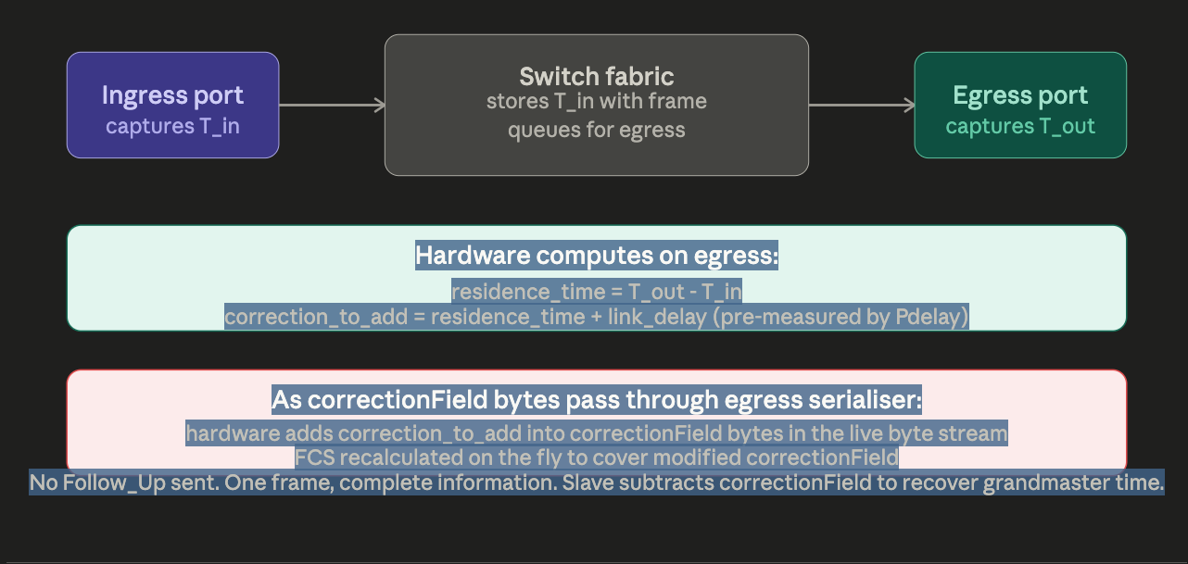
There is a refinement used in gPTP switches. Instead of modifying originTimestamp (which belongs to the grandmaster and should not be altered), switches use the correctionField. When a one-step transparent clock forwards a Sync, it adds its residence time and link delay into correctionField as the frame passes through — without any Follow_Up.

The single most important point from the comparison — and the one most often misunderstood — is that one-step and two-step achieve identical accuracy when both use hardware timestamps. The accuracy of PTP comes entirely from the quality of the hardware timestamp itself (how close the latch is to the true SFD crossing) and from the servo's ability to filter noise. Whether T1 travels in the Sync or in a Follow_Up makes no difference to the timestamp's precision.
One-step's real advantage is reduced message count and lower slave complexity — the slave does not need to buffer Sync frames waiting for their Follow_Up, does not need to correlate pairs by sequenceId, and does not face the failure mode of a Sync arriving without a Follow_Up. In a vehicle with dozens of gPTP nodes all exchanging Pdelay messages continuously, halving the PTP management traffic has meaningful value. This is why IEEE 802.1AS-2025 marks one-step as the preferred mode for automotive deployments.

